**PersonaKitty**

**YDRRSSL Studio**

Ridwan Hanif Abdurrasyid 2001589996

Sarah Rahma Suryaningrum 2001569155

Richky Gani Artha 2001577996

School of Computer Science / Game Application and Technology

Bina Nusantara University

Jakarta

2018

**Table of Contents**

**Overview** 3

* Theme/Setting/Genre 3
* Core Gameplay Mechanic 3
* Targeted Platforms 4
* Project Scope 4
* Influences 4
* The Elevator Pitch 5
* Project Description 5

**Mechanic and Gameplay** 6

* Pet 6
* Affection Meter and Points 6
* Actions 7
* Feeding Mini Game 7

**Monetization** 8

**Assets** 9

**Schedule** 12

**Bibliography** 13

**Overview**

**Theme, Setting, and Genre**

PersonaKitty is a 2D Simulation Game where players will interact with a Virtual Pet that has an anger management problem. This game is aimed to be played especially by people with anger management problem, so they can relate with their pet and try to solve the pet’s anger, and at the same time they can also look at their anger problem with the angle of an observer (player).

**Genre** : 2D, Simulation, Virtual Pet, Puzzle Mini Game

**Core Gameplay Mechanic**

* **Pet**

PersonaKitty provides you with a grumpy pet that has to be attended and cared by to slowly open up to you. Your Care and Affection will raise the Affection Meter of the pet.

* **Affection Meter and Points**

Affection Meter shows the mood swing of the pet, it can be negative or positive according to your Actions which gives out Affection Points. Affection Meter main function is to change the pet’s reaction/feeling towards you (Cold – Warm).

* **Action**

There are 3 types of actions available for the player, each with their own cooldown and Affection Points. In name, they are: Feed, Play, and Pet. The effectiveness of the actions depends on the Affection Meter of the per, for example is when the pet has bad mood, they won’t want to play and be touched.

* **Action Cooldown**

To not let the actions be spammed, and also to not make the player stares at their phone all day, we give each actions cooldown, just like caring for a real pet. Eat for 3 times a day, playing once each hour, only petting the pet has no cooldown, but the effectiveness will drop until the pet feel irritated by the player’s touch which in turn drops the Affection Meter.

* **Feeding Mini Game**

When you want to feed the pet, there will be a Puzzle Mini Game to alleviate boredom and gives an extra kick of variety.

* **Interactive Design**

Pet and gimmicks will be interactable to touch and throw to alleviate the anger of the player when the emotion becomes unstable. But, the animation of the throw will be cute, so it won’t aggravate the anger but reduce it.

* **Affection Report**

Affection Meter Log will be saved inside the game and can be accessed later by Counseling to see if the game is effective to help the player’s problem or not by seeing the interaction between the player and pet.

**Targeted Platforms**

Android Mobile

**Project Scope**

YDRRSSL Studio will take approximately 6 months to finish PersonaKitty, with detailed timeline provided in the Schedule part.

Team Consists of 7 People

* + - Ridwan Hanif Abdurrasyid Game Designer, Programmer
    - Sarah Rahma Suryaningrum Game Designer
    - Richky Gani Artha Sound Engineer
    - DKV Members Game Artist
      * Yanuar
      * Liferdy
      * Stephanie G
      * Della

**Influences**

**Anger Management**

*The goal of anger management is to reduce both emotional feelings and the physiological arousal that anger causes.* [1]

Mahat Pashupati and Sharma Vidya Dev mentioned in their Journal titled “Anger and It’s Management” that Anger is a completely normal, usually healthy, human emotion. But when it gets out of control and turns destructive, it can lead to problems in different areas of life such as problems at work, in the personal relationships, and in the overall quality of our life. [1]

Then why are some people angrier than the others? Deffenbacher (1999) states that some people really are "hotheaded" than the others. Some people do not express anger overtly. Some people have low tolerance to anger and frustration. One cause for anger reaction may be genetic or physiological: there is evidences that some children are born irritable, touchy, and easily angered from a very early age. Another may be sociocultural: not getting opportunity to learn to handle anger reaction constructively. [2]

In “Anger and It’s Management”, it is also mentioned that there are some ways/strategies to control anger, with some of it will be attempted to be implemented into PersonaKitty. [1] Such as:

* Relaxation
* Change of Environment
* Humor
* Identifying and modifying contextual stressors (Learning the things that result in stress and the way to deal with it)

**Elevator Pitch**

It’s easier to play game rather than reading books about Anger. This is what we aim in making PersonaKitty, to help people know about anger and how to solve them. Especially for people that already has anger problem. We hope that Hulk can change to Bruce banner by playing Personakitty.

**Project Description**

PersonaKitty is a Virtual Pet game that aims to teach players about anger problem, and the way to solve it. Equipped by relaxing music, simple mini games, and warm graphics, we hope that this game can help people to calm their minds and reduce their anger.

**Mechanic and Gameplay**

**Pet**

* Pet can be picked up and moved around
* Pet has different kind of facial feature and speech depending on the Affection Meter.

**Affection Meter and Points**

* Affection Meter
  + Affection Meter divided into 5 part:
    - Hate (0 – 9 Affection Points)
    - Annoyed (10 – 39 Affection Points)
    - Normal (40 – 59 Affection Points)
    - Like (60 – 89 Affection Points)
    - Love (90 – 100 Affection Points)
  + Every Parts will change the way the Heart icon looks.
  + Every Parts has different sets of facial feature and speech for the pet.
* Affection Points
  + Minimum 0 and Maximum 100.
  + Can only be gained through Actions.
  + Every action has different amount of points given.

|  |  |  |  |  |  |
| --- | --- | --- | --- | --- | --- |
| Affection Point | | Increase | | | Affection Meter |
| Min | Max | Food | Pet | Play |
| 0 | 9 | 6 | 0 | 0 | 1 |
| 10 | 19 | 5 | 1 | 0 | 2 |
| 20 | 29 | 4 | 1 | 1 |
| 30 | 39 | 3 | 1 | 2 |
| 40 | 49 | 3 | 2 | 3 | 3 |
| 50 | 59 | 3 | 2 | 4 |
| 60 | 69 | 3 | 1 | 5 | 4 |
| 70 | 79 | 2 | 1 | 4 |
| 80 | 89 | 2 | 1 | 3 |
| 90 | 100 | 2 | 1 | 2 | 5 |

**Actions**

Actions will be programmed to be as real as possible.

* **Feed**
  + Player can feed the pet 3 times a day: morning, noon, and evening.
  + Pet will also remind the player to eat with them.
  + Time will be controlled locally depending on phone’s time.
  + Affection Points for feeding decrease exponentially: the higher the Affection meter, the lower Affection Points this action will give.
  + Forgetting to feed the pet will result in negative Affection Point.
* **Play**
  + Player can play with the pet once every hour
  + Low Affection Meter will result in Pet declining to play with player, thus wasting their playing chance.
  + High Affection Meter will result in high Affection Point.
* **Pet**
  + Player can pet their Pet unlimitedly.
  + But the more the player pet them, the more irritated the pet will be, thus result in negative Affection Point, so pet your pet carefully.

**Feeding Mini Game**

* Feeding Mini Game will be triggered when Feed Button is pressed.
* Puzzle will pop out where a picture of pet food will be scrambled, and the player have to rotate it to become a whole food again.
* The game is aimed to be simple, to not stress out and irritate the player.

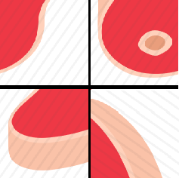

**Monetization**

PersonaKitty implements an in-App Store where Player can spend **Paws** to buy things such as:

* New type of Pet
* Accessories and Toys for their Pet
* Extra UI Themes
* Extra Game Backgrounds
* Extra BGMs

**Paw**

**Paw** is the currency inside PersonaKitty. It can be earned by feeding the pet, watching Ads, or by purchasing it with Real Money.

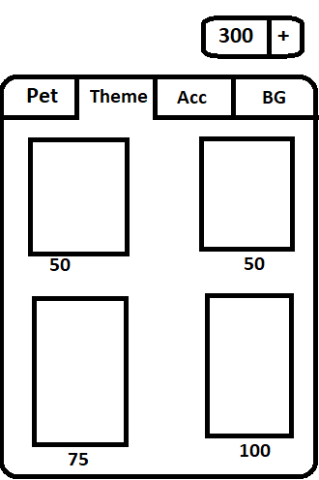

**Assets**

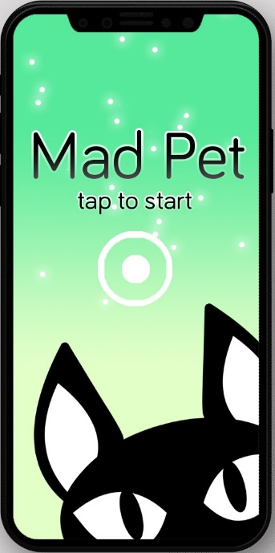

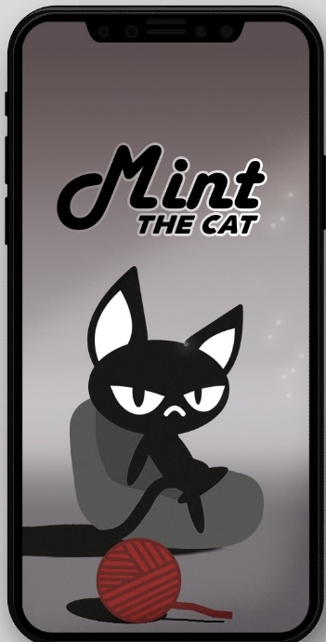

**UI Concept**

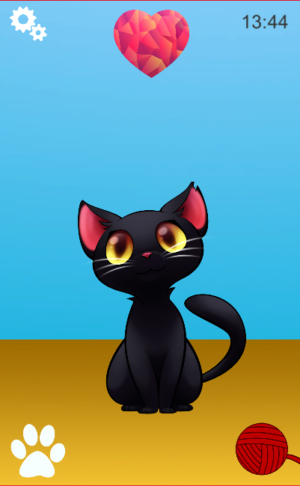

**Schedule**

|  |  |  |  |  |  |  |  |  |  |  |  |  |  |  |  |
| --- | --- | --- | --- | --- | --- | --- | --- | --- | --- | --- | --- | --- | --- | --- | --- |
| **Member** | **Task** | **TimeLine** | | | | | | | | | | | | | |
| **Sep** | **Oct** | | | | **Nov** | | | | **Dec** | | | | **Jan** |
| **4** | **1** | **2** | **3** | **4** | **1** | **2** | **3** | **4** | **1** | **2** | **3** | **4** | **1** |
| Ridwan Hanif A | Concept |  |  |  |  |  |  |  |  |  |  |  |  |  |  |
| Game Design |  |  |  |  |  |  |  |  |  |  |  |  |  |  |
| Level Design |  |  |  |  |  |  |  |  |  |  |  |  |  |  |
| Prototype |  |  |  |  |  |  |  |  |  |  |  |  |  |  |
| Asset Implementation |  |  |  |  |  |  |  |  |  |  |  |  |  |  |
| Debugging |  |  |  |  |  |  |  |  |  |  |  |  |  |  |
| Finalizing |  |  |  |  |  |  |  |  |  |  |  |  |  |  |
| Richky Gani A | Concept |  |  |  |  |  |  |  |  |  |  |  |  |  |  |
| Music Design |  |  |  |  |  |  |  |  |  |  |  |  |  |  |
| Music Implementation |  |  |  |  |  |  |  |  |  |  |  |  |  |  |
| Sarah Rahma S | Concept |  |  |  |  |  |  |  |  |  |  |  |  |  |  |
| Level Design |  |  |  |  |  |  |  |  |  |  |  |  |  |  |
| DKV | Concept |  |  |  |  |  |  |  |  |  |  |  |  |  |  |
| Game Design |  |  |  |  |  |  |  |  |  |  |  |  |  |  |
| UI Design |  |  |  |  |  |  |  |  |  |  |  |  |  |  |
| Assets |  |  |  |  |  |  |  |  |  |  |  |  |  |  |

**Bibiliography**

1. **Pashupati, M., Dev, S.V.** Anger and It’s Management. *In: Journal of Nobel Medical College (2011), Vol. N.1.* [https://www.nepjol.info/index.php/JoNMC/article/download/7282/5898](https://www.google.com/url?sa=t&rct=j&q=&esrc=s&source=web&cd=5&ved=2ahUKEwiTs9yq5v3dAhVLvY8KHV5dD_8QFjAEegQIBhAC&url=https%3A%2F%2Fwww.nepjol.info%2Findex.php%2FJoNMC%2Farticle%2Fdownload%2F7282%2F5898&usg=AOvVaw2Dutf5uySBaxIRMhhkml9O)
2. **Deffenbacher, J.** How to manage Anger: Controlling Anger Before It Controls You. *In: anger control management manual*. APA online: http/www/angermgmt.com.1999